VSCODE PROBLEM SECTION ERROR BUT THE APPLICATIONS AND ENVIRONEMNT SETUP IS PERFEECT

REASON-
Definition:
Pylance is a Language Server for Python in VS Code
🔍 What it actually does:
- Autocomplete (.something)
- Error highlighting (red/yellow lines)
- Type checking
- Import resolution
- IntelliSense suggestions
👉 It does NOT run your code

VS Code has 2 separate systems:
System | What it does
Terminal Python | Runs your project ✅
Pylance (editor) | Shows errors ❌
👉 Right now:
- Terminal → using correct venv ✅
- Pylance → confused / using wrong path ❌
Because it:
- caches old paths
- gets confused after git merge
- fails to detect site-packages sometimes
👉 VERY common issue

Your config is actually correct
This is good:
"python.defaultInterpreterPath": "${workspaceFolder}/vpothole_new/Scripts/python.exe"
And your where python:
vpothole_new\Scripts\python.exe ✅
So backend = solid
✅ PERMANENT FIX (do this once)

🔹 Step 1: Force interpreter again
Even if selected, do again:
Ctrl + Shift + P
→ Python: Select Interpreter
→ Select EXACT:
vpothole_new\Scripts\python.exe

🔹 Step 2: Clear Pylance brain 🧠
Ctrl + Shift + P
→ Python: Restart Language Server
Then:
Ctrl + Shift + P
→ Developer: Reload Window
🧠 1. Why aren’t Terminal and Pylance synchronized?- ⚠️ Why they don’t “communicate”
Because:
- Terminal runs Python in a shell environment
- Pylance runs separately inside VS Code as a static analyzer
👉 They don’t share:
- environment variables fully
- runtime state
- activated venv context (reliably)

Short answer:
❌ They are NOT tightly connected
✅ They are two independent systems

🔹 Think of it like this:
Component | Role
Terminal (Python runtime) | Actually runs your code
Pylance (Language Server) | Just analyzes your code

🔥 Key point:
Terminal = execution engine
Pylance = code analyzer (no execution)

INTEGRATION FRONTEND BACKEND
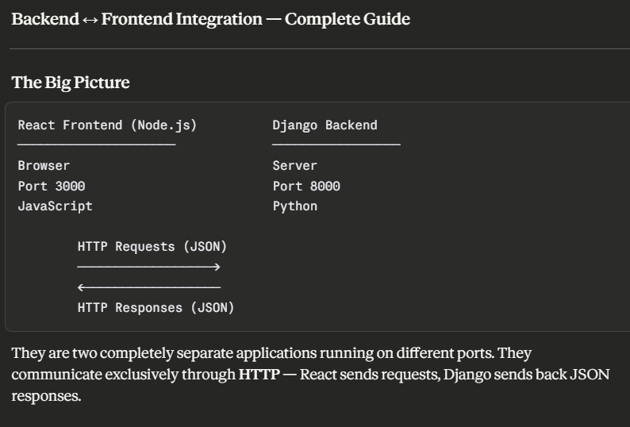

1. The Communication Protocol — REST API
Every piece of data flows through your Django API endpoints:
React wants to start camera detection:
→ POST http://localhost:8000/api/detection/camera/start/
← { "started": true, "message": "Camera detection started." }

React wants detection history:
→ GET http://localhost:8000/api/detection/history/
← [ { "id": 1, "pothole_count": 3, ... }, ... ]

React uploads an image:
→ POST http://localhost:8000/api/detection/detect/
body: FormData { image: <file> }
← { "annotated_image_url": "...", "pothole_count": 2, ... }
2. Dependencies Involved
On the Django side — already done ✅
What | Why
django-cors-headers | Allows React (port 3000) to call Django (port 8000)
djangorestframework | Formats all responses as JSON
Session Auth | Manages login state
On the React side — frontend dev needs these
Package | Purpose | Install
axios | Makes HTTP requests to Django | npm install axios
react-router-dom | Page navigation in React | npm install react-router-dom
js-cookie | Reads CSRF cookie from Django | npm install js-cookie
3. The CORS Problem — Most Critical Concept
CORS = Cross-Origin Resource Sharing
Browser security blocks requests between different origins by default:
React on localhost:3000 → Django on localhost:8000
↑
DIFFERENT ORIGIN = BLOCKED by browser
Your settings.py already has the fix:
python
CORS_ALLOW_ALL_ORIGINS = DEBUG # allows all in development
CORS_ALLOW_CREDENTIALS = True # allows cookies to be sent
In production this must be tightened to:
python
CORS_ALLOWED_ORIGINS = [
"https://your-react-app.com",
]

4. The CSRF Problem — Second Critical Concept
Django protects every POST, PUT, DELETE request with a CSRF token — a security signature that proves the request came from your frontend, not an attacker.
How it flows:
Step 1 — React loads any page
→ Django sets a cookie: csrftoken=abc123

Step 2 — React makes a POST request
→ Must include header: X-CSRFToken: abc123
→ Django verifies it matches the cookie
→ Request allowed ✅

Step 3 — POST without the header
→ Django rejects it: 403 Forbidden ❌
How React reads and sends it:
javascript
// Read the CSRF cookie
import Cookies from 'js-cookie'
const csrfToken = Cookies.get('csrftoken')

// Send it with every POST
axios.post('http://localhost:8000/api/detection/detect/', formData, {
headers: {
'X-CSRFToken': csrfToken,
},
withCredentials: true, // must be true for cookies to work
})

5. Session Authentication Flow
Since you chose Session Auth (not JWT), login works like this:
1. User fills login form in React
↓
2. React POSTs credentials to Django
POST /api/auth/login/
body: { username, password }
↓
3. Django verifies credentials
Creates a session in the database (django_session table)
Sets a cookie: sessionid=xyz789
↓
4. Browser stores the sessionid cookie automatically
↓
5. Every future request from React automatically sends
the sessionid cookie → Django knows who is logged in
↓
6. Logout → Django deletes the session
POST /api/auth/logout/
sessionid cookie is cleared
Key config needed in React — every axios call must have:
javascript
axios.defaults.withCredentials = true
Without this, cookies (sessionid + csrftoken) are never sent and every request appears as anonymous.

6. Every API Endpoint React Will Call
Action | Method | URL | Body | Response
Login | POST | /api/auth/login/ | {username, password} | session cookie set
Logout | POST | /api/auth/logout/ | none | session cleared
Upload image | POST | /api/detection/detect/ | FormData {image} | {annotated_image_url, pothole_count, detections_json}
Detect from URL | POST | /api/detection/detect/ | {image_url} | same as above
Start camera | POST | /api/detection/camera/start/ | none | {started, message}
Stop camera | POST | /api/detection/camera/stop/ | none | {stopped, message}
Camera status | GET | /api/detection/camera/status/ | none | {running, pothole_count, last_detection}
Detection history | GET | /api/detection/history/ | none | [{id, pothole_count, ...}]
Single detection | GET | /api/detection/<id>/ | none | {id, pothole_count, ...}
7. Image Upload — Special Case
Images cannot be sent as JSON. They must be sent as multipart/form-data:
javascript
// React side
const formData = new FormData()
formData.append('image', selectedFile) // selectedFile from <input type="file">

axios.post('http://localhost:8000/api/detection/detect/', formData, {
headers: {
'X-CSRFToken': Cookies.get('csrftoken'),
'Content-Type': 'multipart/form-data',
},
withCredentials: true,
})
Django's DRF already handles this because settings.py has:
python
'DEFAULT_PARSER_CLASSES': [
'rest_framework.parsers.MultiPartParser', # handles file uploads
'rest_framework.parsers.JSONParser',
]

8. The Camera Flow — Special Case
The camera window opens on the server machine (where Django runs), not in the browser. React only controls start/stop via API. The status endpoint lets React poll for live detection data:
React Django Server
────── ─────────────
POST /camera/start/ → Opens webcam window on server
YOLO runs on each frame
Beeps on detection

Every 2 seconds:
GET /camera/status/ → { running: true,
← pothole_count: 2,
last_detection: [...] }

React displays the
detection data in UI

POST /camera/stop/ → Webcam window closes

9. What the Frontend Dev Needs From You
Give your teammate this information:
Base URL:
http://localhost:8000
Required axios config (set once in React):
javascript
import axios from 'axios'

axios.defaults.baseURL = 'http://localhost:8000'
axios.defaults.withCredentials = true
Required header on every POST/PUT/DELETE:
javascript
'X-CSRFToken': Cookies.get('csrftoken')
To get the CSRF cookie initially — React must make one GET request to Django before any POST:
javascript
// Call this once when the app loads
await axios.get('/') // this sets the csrftoken cookie

10. Development vs Production
 | Development | Production
Django URL | http://localhost:8000 | https://api.yourdomain.com
React URL | http://localhost:3000 | https://yourdomain.com
CORS setting | CORS_ALLOW_ALL_ORIGINS = True | CORS_ALLOWED_ORIGINS = [...]
DEBUG | True | False
Static files | Served by Django dev server | Served by Nginx

DATABASE ND SCHEMAS IN BACKEND
A schema in PostgreSQL is a namespace — a named container that sits inside a database and holds tables, views, indexes, and other objects. It lets you group related objects together and keep them separate from others. The hierarchy looks like this:
Cluster (port 5432)
└── Database (e.g. pothole_db)
├── Schema: public ← the default
├── Schema: reporting
└── Schema: analytics
Every PostgreSQL database starts with one schema already created for you called public. When you run python manage.py migrate, all your Django tables land in public by default — you've been using a schema this whole time without thinking about it.

BACKEND TESTING
Perfect. Here's a complete reference for your Django + PostgreSQL + DRF + ML backend.Here's the mental model for testing your specific backend in order, from smallest to largest scope:
1. Test the database layer first
python manage.py check # confirms Django can see your DB config
python manage.py showmigrations # confirms all migrations are applied
python manage.py dbshell # open psql and manually query a table to confirm data
2. Test your models
python manage.py test myapp.tests.ModelTests --verbosity 2
Write a TestCase in tests.py that creates model instances and asserts their fields/relationships save correctly to PostgreSQL.
3. Test your ML / model detection
python manage.py test detection.tests.ModelDetectionTests --verbosity 2
This would be a separate test class where you pass in a known image/input and assert the model returns the expected output/confidence score.
4. Test your DRF API endpoints
python manage.py test myapp.tests.APITests --verbosity 2
Use DRF's APITestCase and APIClient to hit your endpoints and assert correct status codes and response shapes.
5. Test everything at once
python manage.py test --verbosity 2 --keepdb
--keepdb is very useful here — it skips recreating the PostgreSQL test database on every run, which saves a lot of time.
One tip: use python manage.py shell constantly while building. You can import your models, serializers, and even run your ML model manually right there in the terminal without needing a real HTTP request. It's the fastest way to debug.
Click any card above to go deeper on any specific command!
